@Configuration vs @Component (with @Bean)

What Problem Do These Annotations Solve?
Spring needs to know:
Which Java classes should become objects inside the IoC container?
There are two ways to do this:
- Let Spring discover classes automatically → @Component
- Tell Spring explicitly how to create objects → @Configuration + @Bean

@Component — Automatic Bean Creation
What it means
@Component tells Spring:
“This class should be discovered during component scanning and turned into a bean.”

Example
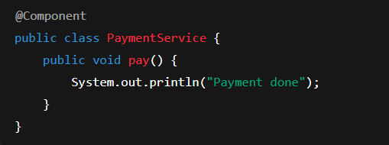
During startup:
- Spring scans packages
- Finds @Component
- Creates object
- Stores it in IoC container

You never control:
- How it is created
- What dependencies are passed Spring does it for you.
@Configuration + @Bean — Explicit Bean Creation
@Configuration is used when:
You want to tell Spring exactly how an object must be created.
Example
@Configuration
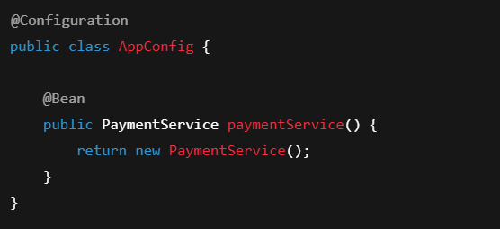
Now Spring does not discover PaymentService.
It executes:
paymentService()
and stores the returned object as a bean.

Why @Configuration Is NOT Just @Component
This is where most people fail interviews.
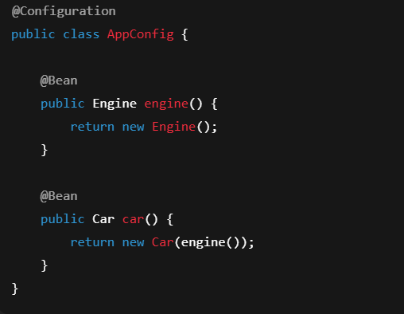
You may think: engine() is called twice → two objects?
No.
Spring uses CGLIB proxy for @Configuration.
It intercepts:
engine() and returns the same bean every time.
This guarantees true singleton behavior.
If you replace @Configuration with @Component:
@Component
public class AppConfig { ... }
Now:
engine()
is called directly → new object created every time → broken singleton.
This is a very common interview trap.

When to Use Which
Situation | Use
Your own classes | @Component, @Service, @Repository
Third-party classes | @Configuration + @Bean
Complex object creation | @Configuration + @Bean
Simple POJOs | @Component

Example:
You cannot put @Component on a library class like DataSource.
So you must use:
@Bean
public DataSource dataSource() { }

Flow Comparison
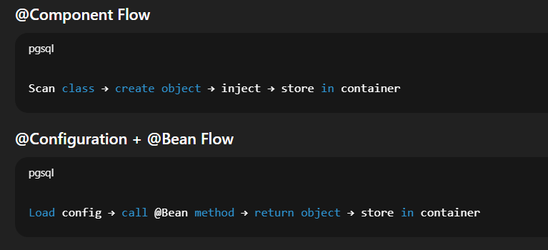

CGLIB Proxy – What Really Happens in @Configuration
CGLIB = Code Generation Library
In Spring:
CGLIB Proxy = a runtime-generated subclass of your class that intercepts method calls
In simple words:
Spring creates a fake child class of your class and puts logic in between.

When you write:
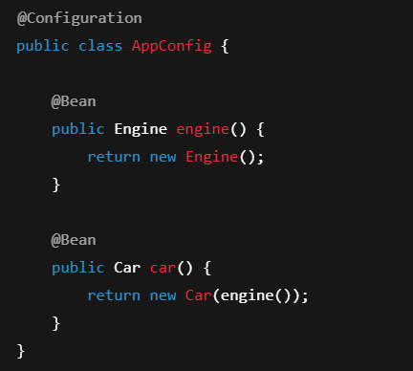
Spring does not use AppConfig directly.
It creates a proxy subclass using CGLIB.
Conceptually:
AppConfig ---> AppConfig$$SpringCGLIBProxy
Every call to a @Bean method goes through this proxy.

What the proxy actually does
When car() calls engine():
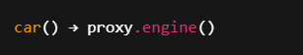
The proxy checks:
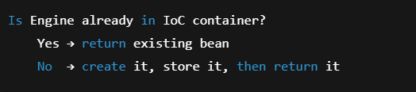
So even though your Java code looks like this:

What actually happens is:

This is why @Configuration guarantees:
- Singleton behavior
- No duplicate objects
- Correct dependency graph

If you use @Component instead
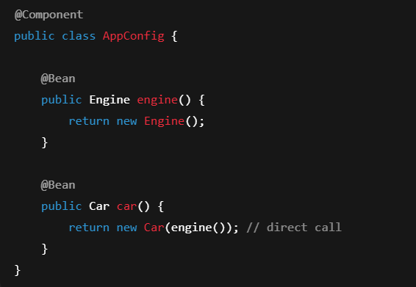
Now there is no proxy.
So:
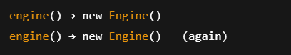
Two different objects → broken singleton → production bugs.
This is one of the most common Spring interview traps.

Bean Creation Cheat-Sheet
Using @Component
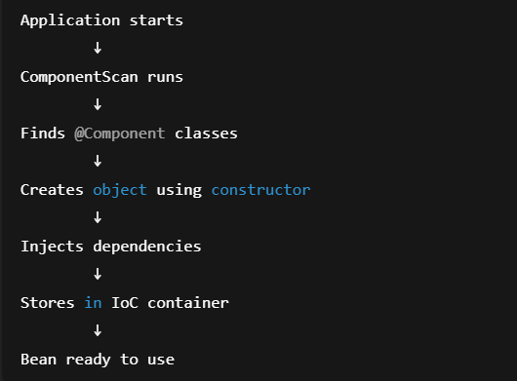
You never control object creation.
Spring decides everything.
Using @Configuration + @Bean
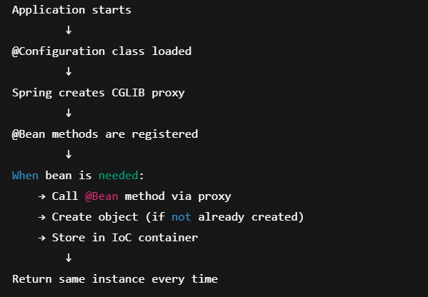
Here you control construction, Spring controls lifecycle.

When to use what (Interview Ready)
Scenario | Use
Your own service, controller, repository | @Component, @Service, @Repository
Third-party class (DataSource, Kafka, SDKs) | @Bean
Complex object creation logic | @Bean
Need to pass constructor params | @Bean
Need conditional creation | @Bean

One-Line Memory Hook
@Component lets Spring discover beans.
@Configuration + @Bean lets you design how beans are built.
Interview-Critical Questions
Q1. Difference between @Component and @Configuration?
@Component marks a class for auto-detection.
@Configuration defines how beans are created explicitly.
Q2. Why does Spring use CGLIB with @Configuration?
To ensure @Bean methods return singleton instances.
Q3. Can @Bean work without @Configuration?
Yes, but singleton behaviour is not guaranteed.
Q4. When should I prefer @Bean over @Component?
When you don’t own the class or need custom construction.
One-Line Interview Summary
“@Component lets Spring discover beans, while @Configuration + @Bean lets you define exactly how beans are created, with proxy-based singleton guarantees.”

